1. Mac Users, open you [terminal](https://macpaw.com/how-to/use-terminal-on-mac), for pc users, open your Ubuntu (linux) app.
2. Generate an ssh key following the steps bellow:
   1. Start in the home directory

* 1. Use the command: ssh-keygen -t rsa

* 1. You do not need to enter a file in which to save the key or a passphrase for the key just enter or return past them.

1. Copy the value of the public SSH key to the clipboard by doing the following:
   1. cat ~/.ssh/id_rsa.pub

* 1. highlight and copy

1. Add SSH key to github
   1. Open and log into github
   2. In account setting go to SSH and GPG Keys

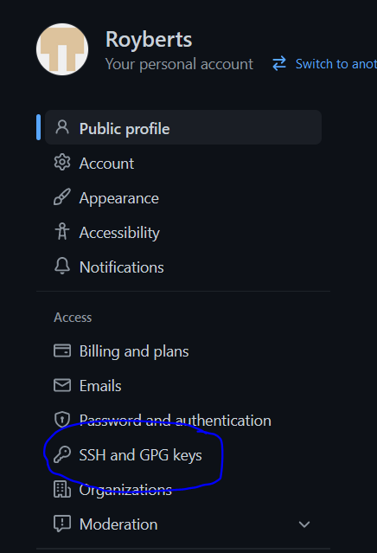

* 1. Click the green New SSH Key button

* 1. Paste in the previously copied key

* 1. Add the key

1. For the SSH key to work, when cloning a repo you must clone the SSH repo and not the HTTPS repo.

1. If a “no such identity” error occurs check and make sure that the config is set up correct.

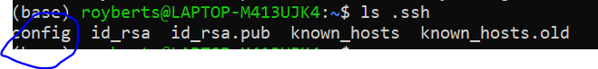

* 1. Make sure that the following line is included: IdentityFile ~/.ssh/id_rsa

